**Definition of Scrum**

Scrum (n): A framework within which people can address complex adaptive problems, while productively and creatively delivering products of the highest possible value.[1]

Scrum is:

* Lightweight
* Simple to understand
* Difficult to master

Scrum is a process framework that has been used to manage complex product development since the early 1990s. Scrum is not a process or a technique for building products; rather, it is a framework within which you can employ various processes and techniques. Scrum makes clear the relative efficacy of your product management and development practices so that you can improve.[2]

The Scrum framework consists of Scrum Teams and their associated roles, events, artifacts, and rules. Each component within the framework serves a specific purpose and is essential to Scrum’s success and usage.[3]

The rules of Scrum bind together the events, roles, and artifacts, governing the relationships and interaction between them. [4]

**Scrum Theory**

Scrum is founded on empirical process control theory, or empiricism. Empiricism asserts that knowledge comes from experience and making decisions based on what is known. Scrum employs an iterative, incremental approach to optimize predictability and control risk. [5]

Three pillars uphold every implementation of empirical process control: transparency, inspection, and adaptation.[6]

* **Transparency:** Significant aspects of the process must be visible to those responsible for the outcome. Transparency requires those aspects be defined by a common standard so observers share a common understanding of what is being seen. For example: A common language referring to the process must be shared by all participants; and, Those performing the work and those accepting the work product must share a common definition of “Done”.
* **Inspection:** Scrum users must frequently inspect Scrum artifacts and progress toward a Sprint Goal to detect undesirable variances. Their inspection should not be so frequent that inspection gets in the way of the work. Inspections are most beneficial when diligently performed by skilled inspectors at the point of work.
* **Adaptation:** If an inspector determines that one or more aspects of a process deviate outside acceptable limits, and that the resulting product will be unacceptable, the process or the material being processed must be adjusted. An adjustment must be made as soon as possible to minimize further deviation.

**Scrum Principles**

Scrum principles are the core guidelines for applying the Scrum framework and should mandatorily be used in all scrum projects. The six Scrum principles are: Empirical Process Control, Self-Organization, Collaboration, Value-Based Prioritization, Time-Boxing, and Iterative Development.[7]

Scrum principles can be applied to any type of project in any organization and must be adhered to in order to ensure effective implementation of the Scrum framework. Scrum Principles are non-negotiable and must be applied. Keeping the principles intact and using them appropriately instills confidence in the Scrum framework with regard to attaining the objectives of the project. [8]

* **Empirical Process Control:** This principle emphasizes the core philosophy of Scrum based on the three main ideas of transparency, inspection, and adaptation.
* **Self-organization**: This principle focuses on today’s workers, who deliver significantly greater value when self-organized and this results in better team buy-in and shared ownership; and an innovative and creative environment which is more conducive for growth .
* **Collaboration**: This principle focuses on the three core dimensions related to collaborative work: awareness, articulation, and appropriation. It also advocates project management as a shared value-creation process with teams working and interacting together to deliver the greatest value.
* **Value-based Prioritization**: This principle highlights the focus of Scrum to deliver maximum business value, from early in the project and continuing throughout.
* **Time-boxing**: This principle describes how time is considered a limiting constraint in Scrum, and
* used to help effectively manage project planning and execution. Time -boxed elements in Scrum include Sprints, Daily Standup Meetings, Sprint Planning Meetings, and Sprint Review Meetings.
* **Iterative Development**: This principle defines iterative development and emphasizes how to better manage changes and build products that satisfy customer needs. It also delineates the Product Owner’s and organization’s responsibilities related to iterative development.

**Scrum Framework**

Scrum is a framework for developing and sustaining complex products. This definition consists of Scrum’s roles, events, artifacts, and the rules that bind them together. [9]

**The Scrum Team**

The Scrum Team consists of a Product Owner, the Development Team, and a Scrum Master. Scrum Teams are self-organizing and cross-functional. Self-organizing teams choose how best to accomplish their work, rather than being directed by others outside the team. Cross-functional teams have all competencies needed to accomplish the work without depending on others not part of the team. The team model in Scrum is designed to optimize flexibility, creativity, and productivity.[10]

Scrum Teams deliver products iteratively and incrementally, maximizing opportunities for feedback. Incremental deliveries of “Done” product ensure a potentially useful version of working product is always available.[11]

**Scrum Events**

Prescribed events are used in Scrum to create regularity and to minimize the need for meetings not defined in Scrum. All events are time-boxed events, such that every event has a maximum duration. Once at Sprint begins, its duration is fixed and cannot be shortened or lengthened. The remaining events may end whenever the purpose of the event is achieved; ensuring an appropriate amount of time is spent without allowing waste in the process.[12]

Other than the Sprint itself, which is a container for all other events, each event in Scrum is a formal opportunity to inspect and adapt something. These events are specifically designed to enable critical transparency and inspection. Failure to include any of these events results in reduced transparency and is a lost opportunity to inspect and adapt.[13]

Scrum prescribes four formal events for inspection and adaptation, as described in the Scrum Events section of this document[14]:

* Sprint Planning
* Daily Scrum
* Sprint Review
* Sprint Retrospective
* Backlog Grooming/Refinement

**Scrum Artifacts**

Scrum’s artifacts represent work or value to provide transparency and opportunities for inspection and adaptation. Artifacts defined by Scrum are specifically designed to maximize transparency of key information so that everybody has the same understanding of the artifact.[15]

As a consequence, Scrum does not prescribe how the team goes about its work in the sprint; the team uses inspect-and-adapt to manage and optimize its work. Another consequence is the lack of sophisticated reporting; customers, users and management is expected to attend the sprint review meeting to understand what the project has achieved and help maximize the likelihood of creating a successful product. [16]

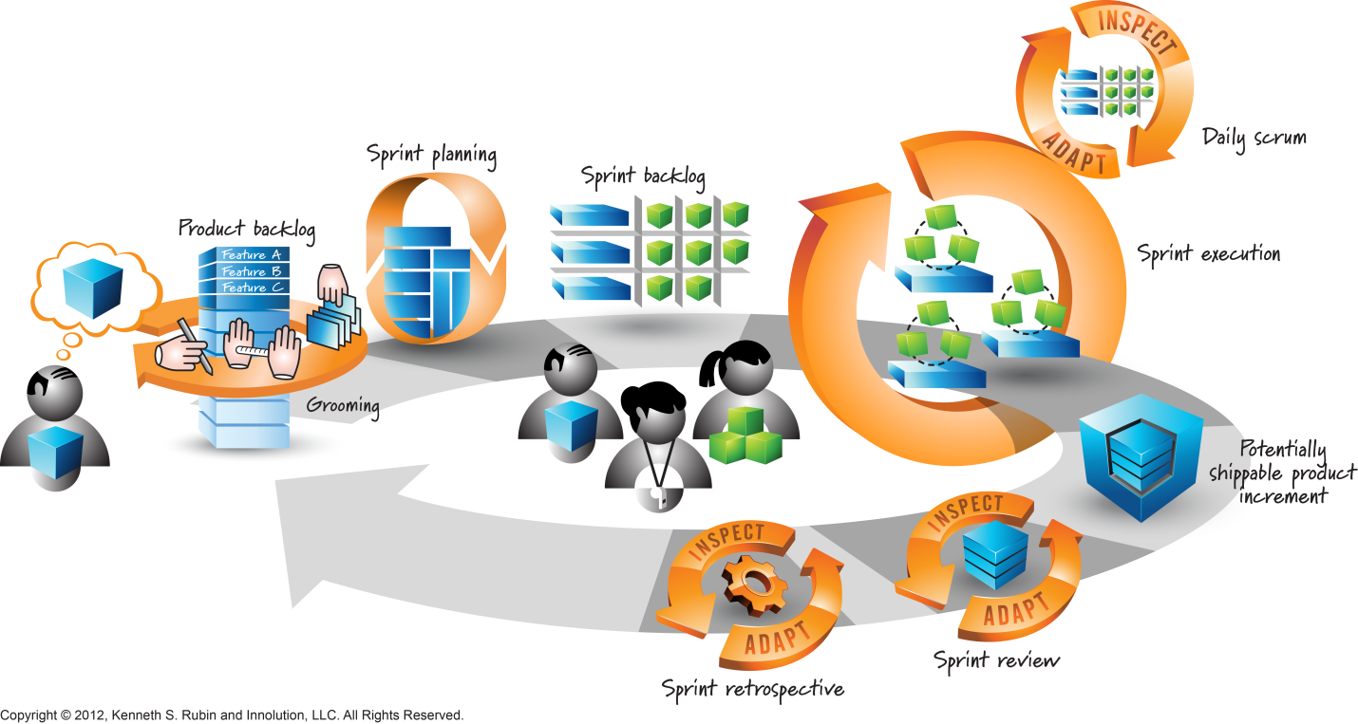**[17]**

**Overview of Scrum**

A Scrum project involves a collaborative effort to create a new product, service, or other result as defined in the Project Vision Statement. Projects are impacted by constraints of time, cost, scope, quality, resources, organizational capabilities, and other limitations that make them difficult to plan, execute, manage, and ultimately succeed. However, successful implementation of the results of a finished project provides significant business benefits to an organization. It is therefore important for organizations to select and practice an appropriate project management methodology. [18]

Scrum is one of the most popular Agile methodologies. It is an adaptive, iterative, fast, flexible, and effective methodology designed to deliver significant value quickly and throughout a project. Scrum ensures transparency in communication and creates an environment of collective accountability and continuous progress. The Scrum framework, as defined in the SBOK™ Guide, is structured in such a way that it supports product and service development in all types of industries and in any type of project, irrespective of its complexity.[19]

A key strength of Scrum lies in its use of cross -functional, self-organized, and empowered teams who divide their work into short, concentrated work cycles called Sprints.[20]

The Scrum cycle begins with a Stakeholder Meeting, during which the Project Vision is created. The Product Owner then develops a Prioritized Product Backlog which contains a prioritized list of business and project requirements written in the form of User Stories. Each Sprint begins with a Sprint Planning Meeting during which high priority User Stories are considered for inclusion in the Sprint. A Sprint generally lasts between one and six weeks and involves the Scrum Team working to create potentially shippable Deliverables or product increments. During the Sprint, short, highly focused Daily Standup Meetings are conducted where team members discuss daily progress. Toward the end of the Sprint, a Sprint Review Meeting is held during which the Product Owner and relevant stakeholders are provided a demonstration of the Deliverables. The Product Owner accepts the Deliverables only if they meet the predefined Acceptance Criteria. The Sprint cycle ends with a Retrospect Sprint Meeting where the team discusses ways to improve processes and performance as they move forward into the subsequent Sprint.[21]

**Brief History of Scrum**

In the mid 80’s, Hirotaka Takeuchi and Ikujiro Nonaka defined a flexible and all-inclusive product development strategy where the development team works as a unit to reach a common goal. They described an innovative approach to product development that they called a holistic or “rugby” approach, “where a team tries to go the distance as a unit, passing the ball back and forth.” They based their approach on manufacturing case studies from various industries. Takeuchi and Nonaka proposed that product development should not be like a sequential relay race, but rather should be analogous to the game of rugby where the team works together, passing the ball back and forth as they move as a unit down the field. The rugby concept of a “Scrum” (where a group of players form together to restart the game) was introduced in this article to describe the authors’ proposal that product development should involve “moving the Scrum downfield”.[22]

Ken Schwaber and Jeff Sutherland elaborated on the Scrum concept and its applicability to software development in a presentation at the Object-Oriented Programming, Systems, Languages & Applications (OOPSLA) conference held in 1995 in Austin, Texas. Since then, several Scrum practitioners, experts, and authors have continued to refine the Scrum conceptualization and methodology. In recent years, Scrum has increased in popularity and is now the preferred project development methodology for many organizations globally.[23]

**Where Scrum Works[24]**

Complexity zone: There is a large area on this diagram which lies between the anarchy region and regions of the traditional management approaches. Stacey calls this large center region the zone of complexity - others call it the edge of chaos. In the zone of complexity the traditional management approaches are not very effective but it is the zone of high creativity, innovation, and breaking with the past to create new modes of operating.”[25]

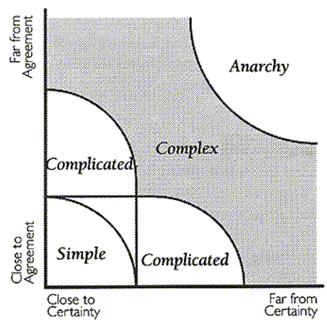

**Why Use Scrum**

Some of the key benefits of using Scrum in any project are[26]:

* **Adaptability**—Empirical process control and iterative delivery make projects adaptable and open to incorporating change.
* **Transparency**—All information radiators like a Scrum board and Sprint Burndown Chart are shared, leading to an open work environment.
* **Continuous Feedback**—Continuous feedback is provided through the Conduct Daily Standup, and Demonstrate and Validate Sprint processes.
* **Continuous Improvement**—The deliverables are improved progressively Sprint by Sprint, through the Groom Prioritized Product Backlog process.
* **Continuous Delivery of Value**—Iterative processes enable the continuous delivery of value through the Ship Deliverables process as frequently as the customer requires.
* **Sustainable Pace**—Scrum processes are designed such that the people involved can work at a sustainable pace that they can, in theory, continue indefinitely.
* **Early Delivery of High Value**—The Create Prioritized Product Backlog process ensures that the highest value requirements of the customer are satisfied first.
* **Efficient Development Process**—Time-boxing and minimizing non-essential work leads to higher efficiency levels.
* **Motivation**—The Conduct Daily Standup and Retrospect Sprint processes lead to greater levels of motivation among employees.
* **Faster Problem Resolution**—Collaboration and colocation of cross-functional teams lead to faster problem solving.
* **Effective Deliverables**—The Create Prioritized Product Backlog process and regular reviews after creating deliverables ensures effective deliverables to the customer.
* **Customer Centric**—Emphasis on business value and having a collaborative approach to stakeholders ensures a customer-oriented framework.
* **High Trust Environment**—Conduct Daily Standup and Retrospect Sprint processes promote transparency and collaboration, leading to a high trust work environment ensuring low friction among employees.
* **Collective Ownership**—The Approve, Estimate, and Commit User Stories process allows team members to take ownership of the project and their work leading to better quality.
* **High Velocity**—A collaborative framework enables highly skilled cross-functional teams to achieve their full potential and high velocity.
* **Innovative Environment**—The Retrospect Sprint and Retrospect Project processes create an environment of introspection, learning, and adaptability leading to an innovative and creative work environment.

**Scrum Values[27]**

“All work performed in Scrum needs a set of values as the foundation for the team's processes and interactions. And by embracing these five values, the team makes them even more instrumental to its health and success.

* **Focus**: Because we focus on only a few things at a time, we work well together and produce excellent work. We deliver valuable items sooner.
* **Courage**: Because we work as a team, we feel supported and have more resources at our disposal. This gives us the courage to undertake greater challenges.
* **Openness**: As we work together, we express how we're doing, what's in our way, and our concerns so they can be addressed.
* **Commitment**: Because we have great control over our own destiny, we are more committed to success.
* **Respect**: As we work together, sharing successes and failures, we come to respect each other and to help each other become worthy of respect.

As an organization applies Scrum it discovers its benefits. At the same time, it sees how these values inherently contribute to the success of Scrum and understands why they are both needed, and bolstered, by Scrum.”

**Note from Scrum.org**

Scrum is free and offered in the Scrum Guide. Scrum’s roles, artifacts, events, and rules are immutable and although implementing only parts of Scrum is possible, the result is not Scrum. Scrum exists only in its entirety and functions well as a container for other techniques, methodologies, and practices.[28]

**Self-Assessment: Scrum Foundations**

* **Empirical and defined processes**: Define and describe the two terms, including a description of inspect, adapt, and transparency as the three legs of an empirical process. Describe how the Scrum Framework is based on empirical process.[29]
* **The Five Scrum Values:** Identify the five Scrum values, and use examples of how Scrum practices support the application of each.[30]
* **Applicability of Scrum**: Identify the environments in which the application of Scrum would lead to excellent results.[31]
* **Scrum Flow**: Understand the Scrum Flow, the core components of the Scrum framework, and the Scrum vocabulary[32]
* **Scrum Framework**: Understand the concepts of the Scrum Framework: ScrumMaster, product owner and team; the product backlog as a list of product features and deliverables that is detailed appropriately, emergent, estimated, and prioritized; the sprint with its four meetings and two inspect-and-adapt cycles; the sprint’s outcome, a potentially shippable increment of functionality (product increment). Understand that the elements of the framework are mandatory and must not be compromised. [33]
* **Overview of Scrum Roles:** Identify the three scrum roles and describe why these roles form the scrum team.[34]
* **No Project Manager**: Analyze why the project manager role is not present in the Scrum Framework.[35]
* **Specialists**: Describe how highly specialized roles like business analyst specialized and software architect are likely to change in Scrum[36]
* **Sprint**: Understand the properties of sprints: Timeboxed, protected from any changes, maximum duration is a calendar month. [37]
* **Scrum Work Culture**: Characterize the work environment Scrum creates: People collaborate, enjoy their work and create software that benefits its users and customers.

1. SG
2. SG
3. SG
4. SG
5. SG
6. SG
7. Scrum Book of Knowledge, SBOK, www.scrumstudy.com
8. SBOK
9. Scrum Guide July 2013, [www.scrumguides.org](http://www.scrumguides.org)
10. Scrum Guide July 2013, [www.scrumguides.org](http://www.scrumguides.org)
11. SG
12. SG
13. SG
14. SG
15. SG
16. CSPO Learning Objectives, Scrum Alliance, D-wwwwww8_2.scrumalliance.orgCMSsystemresource_files00004365CSPO_Learning_Objectives.053113.pdf
17. Graphic from Visual AGILExicon, which is a trademark of Innolution LLC and Kenneth S Rubin. http://www.innolution.com/resources/visual-agilexicon-attribution
18. Scrum Book of Knowledge SBOK, [www.scrumstudy.com](http://www.scrumstudy.com)
19. SBOK
20. SBOK
21. SBOK
22. SBOK
23. SBOK
24. The Stacey Matrix, Stacey RD. Strategic management and organizational dynamics: the challenge of complexity. 3rd ed. Harlow: Prentice Hall, 2002.
25. The Stacey Matrix, B Zimmerman, <http://www.gp-training.net/training/communication_skills/consultation/equipoise/complexity/stacey.htm>
26. SBOK
27. <https://www.scrumalliance.org/why-scrum/core-scrum-values-roles#sthash.UHka4uMP.dpuf>
28. SG
29. CSM Content Outline Learning Objectives, www.scrumalliance.org
30. CSM
31. CSM
32. CSPO Learning Objectives, [www.scrumalliance.org](http://www.scrumalliance.org)
33. CSPO
34. CSM
35. CSM
36. CSM
37. CSPO