Article: <https://hbr.org/1986/01/the-new-new-product-development-game>

Explain the relay race metaphor concerning traditional project management as shown in the exhibit below and the differences with a rugby metaphor approach to project management and development.

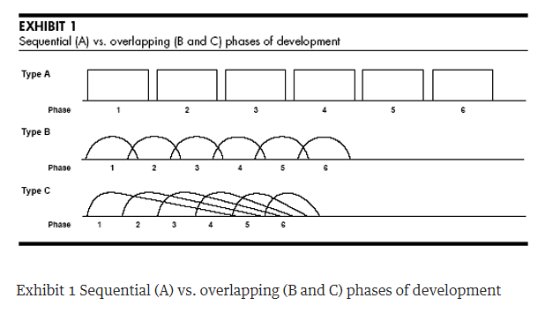

Explain the lessons learned from leading companies:

- Explain "built-in instability" and provide examples

- Explain "self-organization project teams" and provide examples

- Explain "overlapping development phases" and provide examples

- Explain "multi-learning" and provide examples

- Explain "subtle control" and provide examples

- Explain "organizational transfer of learning" and provide examples