**Scrum Team / Delivery Team (aka The Development Team)**

The Scrum Team is a group or team of people who are responsible for understanding the business

requirements specified by the Product Owner, estimating User Stories, and final creation of the project Deliverables.[1]

The Development Team consists of professionals who do the work of delivering a potentially releasable Increment of “Done” product at the end of each Sprint. Only members of the Development Team create the Increment.[2]

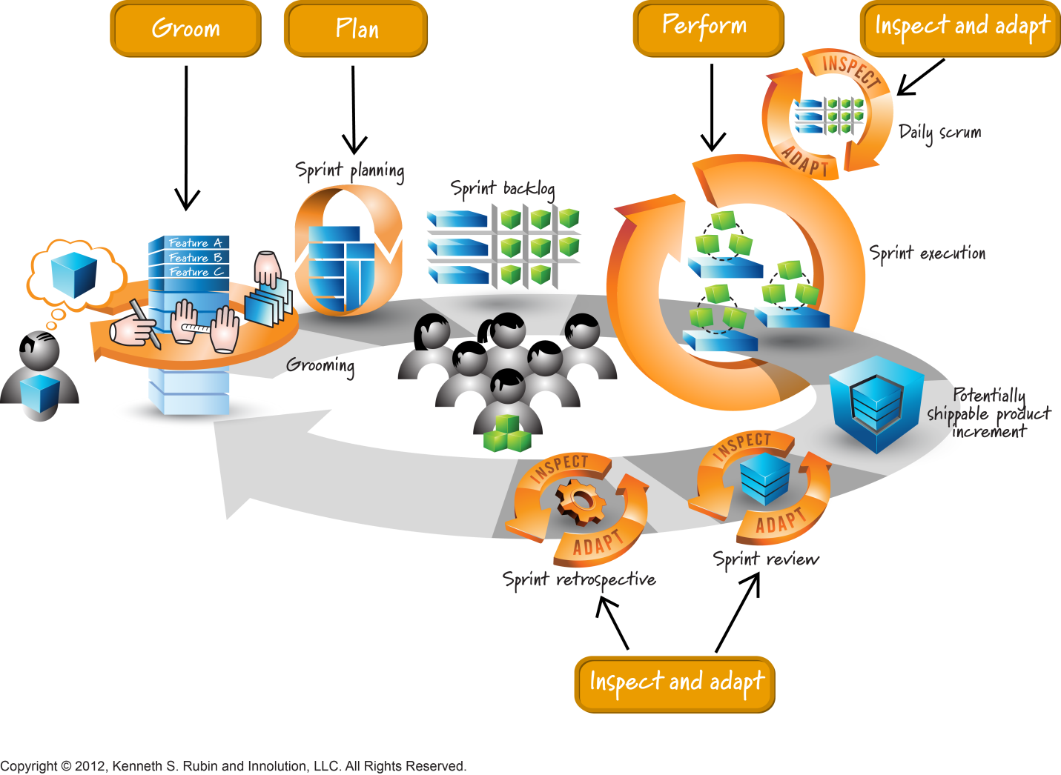[3]

Development Teams are structured and empowered by the organization to organize and manage their own work. The resulting synergy optimizes the Development Team’s overall efficiency and effectiveness. Development Teams have the following characteristics[4]:

* They are self-organizing. No one (not even the Scrum Master) tells the Development Team how to turn Product Backlog into Increments of potentially releasable functionality;
* Development Teams are cross-functional, with all of the skills as a team necessary to create a product Increment;
* Scrum recognizes no titles for Development Team members other than Developer, regardless of the work being performed by the person; there are no exceptions to this rule;
* Scrum recognizes no sub-teams in the Development Team, regardless of particular domains that need to be addressed like testing or business analysis; there are no exceptions to this rule; and,
* Individual Development Team members may have specialized skills and areas of focus, but accountability belongs to the Development Team as a whole.

**Development Team Size**

Optimal Development Team size is small enough to remain nimble and large enough to complete significant work within a Sprint. Fewer than three Development Team members decrease interaction and results in smaller productivity gains. Smaller Development Teams may encounter skill constraints during the Sprint, causing the Development Team to be unable to deliver a potentially releasable Increment. Having more than nine members requires too much coordination. Large Development Teams generate too much complexity for an empirical process to manage. The Product Owner and Scrum Master roles are not included in this count unless they are also executing the work of the Sprint Backlog.[5]

**Assessment: Scrum / Delivery Team**

**1. Responsibilities[6]**

* **Self-Organizing and Whole Team Accountability**: Analyze the reasons and implications of self-organization and whole Team accountability in Scrum, and identify the reasons to not have an appointed Team leader.
* **Delivers a Product Increment:** Describe the importance of creating a potentially shippable product increment in every Sprint, and what it means for the Team composition and collaboration.
* **Manages the Sprint Backlog and Sprint Progress Tracking:** Describe how the Team creates and maintains the Sprint Backlog and tracks Sprint progress.
* Participates in Sprint Meetings: Identify the role the Team plays in Sprint Planning meeting, Sprint Review meeting, Daily Scrum meeting, and Sprint Retrospective. Describe how the team interacts and contributes to reach each meeting goal.

**2. Authority[7]**

* Describe the authority given to the Team and the balance with the responsibility the Team is accountable for. Identify the scope in which the Team authority is valid.

3. **Teamwork[8]**

* Describe how building a highly productive Team takes time and patience and that the Team will need to be guided through this journey by the ScrumMaster. Identify why it is more important that the Team succeeds than any individual member of the Team.

4. **Team Characteristics[9]**

* Identify the desirable characteristics of the Team in terms of its size, proximity, skills, and time availability.

1. A Guide to Scrum Book of Knowledge (SBOK Guide) 2013ed., [www.scrumstudy.com](http://www.scrumstudy.com)
2. Scrum Guide 2016, [www.scrumguides.org](http://www.scrumguides.org)
3. Graphic from Visual AGILExicon, which is a trademark of Innolution LLC and Kenneth S Rubin. http://www.innolution.com/resources/visual-agilexicon-attribution
4. SG
5. SG
6. Certified ScrumMaster (CSM) Content Outline and Learning Objectives, [www.scrumalliance.org](http://www.scrumalliance.org)
7. CSM
8. CSM
9. CSM