**Sprint Backlogs**

The Sprint Backlog is the set of Product Backlog items selected for the Sprint, plus a plan for delivering the product Increment and realizing the Sprint Goal. The Sprint Backlog is a forecast by the Development Team about what functionality will be in the next Increment and the work needed to deliver that functionality into a “Done” Increment.[1]

The Sprint Backlog makes visible all of the work that the Development Team identifies as necessary to meet the Sprint Goal.[2]

The Sprint Backlog is a plan with enough detail that changes in progress can be understood in the Daily Scrum. The Development Team modifies the Sprint Backlog throughout the Sprint, and the Sprint Backlog emerges during the Sprint. This emergence occurs as the Development Team works through the plan and learns more about the work needed to achieve the Sprint Goal.[3]

As new work is required, the Development Team adds it to the Sprint Backlog. As work is performed or completed, the estimated remaining work is updated. When elements of the plan are deemed unnecessary, they are removed. Only the Development Team can change its Sprint Backlog during a Sprint. The Sprint Backlog is a highly visible, real-time picture of the work that the Development Team plans to accomplish during the Sprint, and it belongs solely to the Development Team.[4]

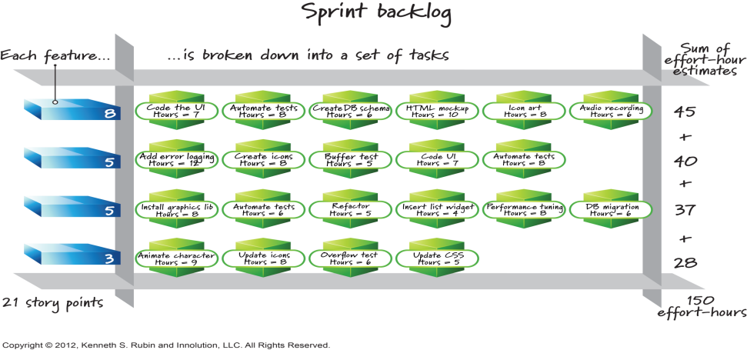[5]

**Self- Assessment:**

**Definition**: Identify the Sprint Backlog as the Team’s plan for how it is going to turn the Product Backlog items selected for a Sprint into potentially shippable functionality.[6]

**Purpose**: Describe the Sprint Backlog’s two main purposes: a detailed view of the Team's expected work for a Sprint and a tool for the Team to manage itself during the Sprint.[7]

**Management:** Define and describe at least one technique for managing the Sprint Backlog (e.g., a Sprint Backlog task board).[8]

**Responsibility:** Describe the responsibility of the Team for creating and maintaining the Sprint Backlog.[9]

**Update Scope**: Identify that the Sprint Backlog should, at all times, show what items are being worked on and by whom. Sometimes the Sprint Backlog should also show how much effort is still required to complete these items.[10]

**Update Frequency:** Describe the need for the Team to update the Sprint Backlog at least once a day.[11]

**Estimation**: Understand that sprint backlog items (tasks) are each estimated, commonly in hours. Understand one or more estimating units for product backlog items, such as story points or ideal days. [12]

1. Scrum Guide July 2016, [www.scrumguides.org](http://www.scrumguides.org)
2. SG
3. SG
4. SG
5. Agilexicon, <http://www.innolution.com/resources/visual-agilexicon-attribution>
6. CSM Learning Objectives, [www.scrumalliance.org](http://www.scrumalliance.org)
7. CSM
8. CSM
9. CSM
10. CSM
11. CSM
12. CSPO Learning Objectives, [www.scrumalliance.org](http://www.scrumalliance.org)