**Scrum Master**

The Scrum Master is responsible for ensuring Scrum is understood and enacted. Scrum Masters do this by ensuring that the Scrum Team adheres to Scrum theory, practices, and rules.[1]

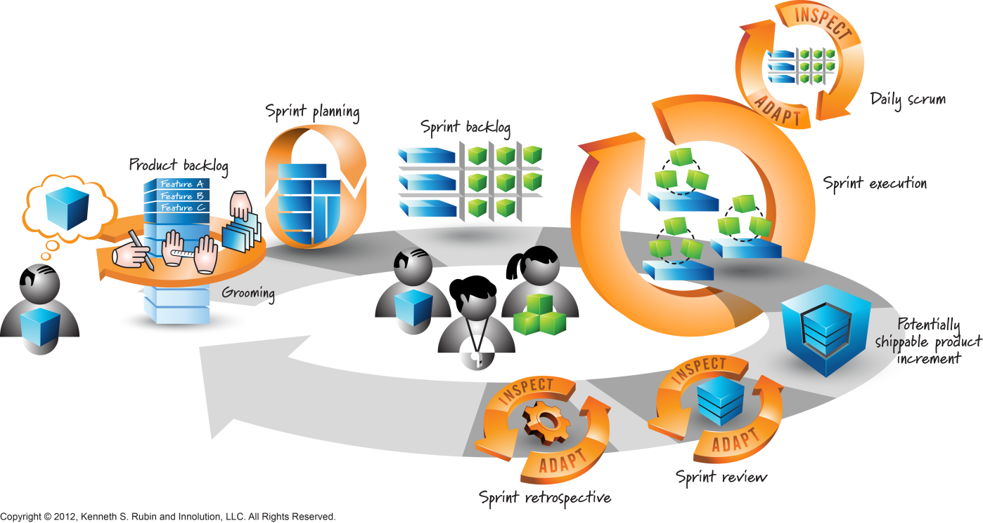[2]

The Scrum Master is a servant-leader for the Scrum Team. The Scrum Master helps those outside the Scrum Team understand which of their interactions with the Scrum Team are helpful and which aren’t. The Scrum Master helps everyone change these interactions to maximize the value created by the Scrum Team.[3]

The Scrum Master is a facilitator who ensures that the Scrum Team is provided with an environment conducive to completing the product’s development successfully. The Scrum Master

guides, facilitates, and teaches Scrum practices to everyone involved in the project; clears impediments for the team; and, ensures that Scrum processes are being followed. [4]

Note that the Scrum Master role is very different from the role played by the Project Manager in a traditional Waterfall model of project management, in which the Project Manager works as a manager or leader for the project. The Scrum Master only works as a facilitator and he or she is at the same hierarchical level as anyone else in the Scrum Team —any person from the Scrum Team who learns how to facilitate Scrum projects can become the Scrum Master for a project or for a

Sprint. Corresponding to a Scrum Master role in a project, there could be a Program Scrum Master for a program or a Portfolio Scrum Master for a portfolio.[5]

**Scrum Master Service to the Product Owner[6]**

The Scrum Master serves the Product Owner in several ways, including:

* Finding techniques for effective Product Backlog management;
* Helping the Scrum Team understand the need for clear and concise Product Backlog items;
* Understanding product planning in an empirical environment;
* Ensuring the Product Owner knows how to arrange the Product Backlog to maximize value;
* Understanding and practicing agility; and,
* Facilitating Scrum events as requested or needed.

**Scrum Master Service to the Development Team[7]**

The Scrum Master serves the Development Team in several ways, including:

* Coaching the Development Team in self-organization and cross-functionality;
* Helping the Development Team to create high-value products;
* Removing impediments to the Development Team’s progress;
* Facilitating Scrum events as requested or needed; and,
* Coaching the Development Team in organizational environments in which Scrum is not yet fully adopted and understood.

**Scrum Master Service to the Organization[8]**

The Scrum Master serves the organization in several ways, including:

* Leading and coaching the organization in its Scrum adoption;
* Planning Scrum implementations within the organization;
* Helping employees and stakeholders understand and enact Scrum and empirical product
* development;
* Causing change that increases the productivity of the Scrum Team; and,
* Working with other Scrum Masters to increase the effectiveness of the application of Scrum in the organization.

**Assessment: Scrum Master Responsibilities[9]**

1. **Responsibilities**

* **Process-Related Responsibilities**: Describe the responsibilities of the ScrumMaster to implement the Scrum Framework, teach and coach people on how to perform in the various roles.
* **Acts as a Change Agent**: Describe how the ScrumMaster will use the learning points of the Scrum Team to push for changes in the organization in support of Scrum and how the ScrumMaster might do this.
* Serves the Product Owner and Team: Identify how the ScrumMaster helps the Product Owner and Team in being better able to do their jobs by assisting them, facilitating creativity and fostering empowerment.
* **Removes Impediments**: Identify how the ScrumMaster removes impediments
* **Coaches the Product Owner and Team**: Identify how the ScrumMaster coaches the Product Owner and Team by teaching and helping improve productivity, working practices and tools.
* **Protects the Team**: Identify how the ScrumMaster will shield the Team from interruptions or interferences during the Sprint and help ensure the organization respects the commitment of the Team during the Sprint.
* **Guides the Team**: Describe how the ScrumMaster will model the values and principles of Agile and Scrum, encouraging the team to challenge themselves while remaining true to the spirit of Scrum.

1. **Authority**

* Describe how the authority of the ScrumMaster is largely indirect and springs mainly from a deep knowledge of Scrum principles and practices. The ScrumMaster has no authority to make decisions on behalf of the Team, cannot commit to dates of delivery or scope but may enforce the Scrum process.

1. Scrum Guide July 2013, [www.scrumguides.org](http://www.scrumguides.org)
2. Graphic from Visual AGILExicon, which is a trademark of Innolution LLC and Kenneth S Rubin. http://www.innolution.com/resources/visual-agilexicon-attribution
3. SG
4. A Guide to Scrum Book of Knowledge (SBOK Guide) 2013ed., www.scrumstudy.com
5. SBOK
6. Scrum Guide July 2013, [www.scrumguides.org](http://www.scrumguides.org))
7. SG
8. SG
9. [www.scrumalliance.org](http://www.scrumalliance.org); CSM Content Outline and Learning Objectives