**Prioritization**

The Scrum [project] cycle begins with a Stakeholder Meeting, during which the Project Vision is created.[1]

Many techniques can be used. The following are some examples: elevator pitch, vision board, or cereal box [see appendix]. The end goal is to understand the value to the customer, what is in or out of scope, and make priority and decisions based on that vision/value. The product owner is responsible for delivering ROI to the organization. This is realized through a prioritized backlog.

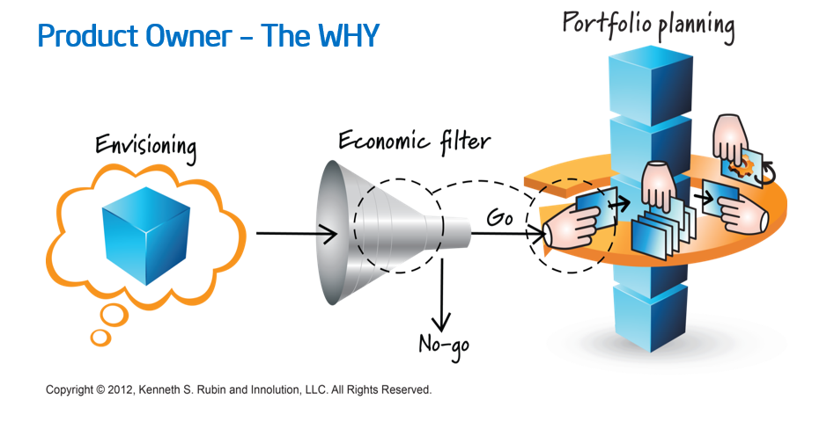[2]

The Product Owner then develops a Prioritized Product Backlog which contains a prioritized list of business and project requirements written in the form of in the form of Epic(s), which are high level User Stories. [3]

The Prioritized Product Backlog is based on three primary factors: value, risk or uncertainty, and dependencies. It is the Product Owner’s responsibility to ensure delivery of those products that provide the highest level of business value first. Even an extremely valuable product may not be part of the first release if there are other products of even higher value that are sufficient for a first release.[4]

Scrum work and deliverables should be prioritized by the right value:

As soon as possible

At the right cost

While managing risks

While balancing stakeholders

In support to the larger organization.

The Product Owner is one person, not a committee. The Product Owner may represent the desires of a committee in the Product Backlog, but those wanting to change a Product Backlog item’s priority must address the Product Owner. [5]

For the Product Owner to succeed, the entire organization must respect his or her decisions. The Product Owner’s decisions are visible in the content and ordering of the Product Backlog. No one is allowed to tell the Development Team to work from a different set of requirements, and the Development Team isn’t allowed to act on what anyone else says.[6]

**Appendix: Project Visions Technique examples**

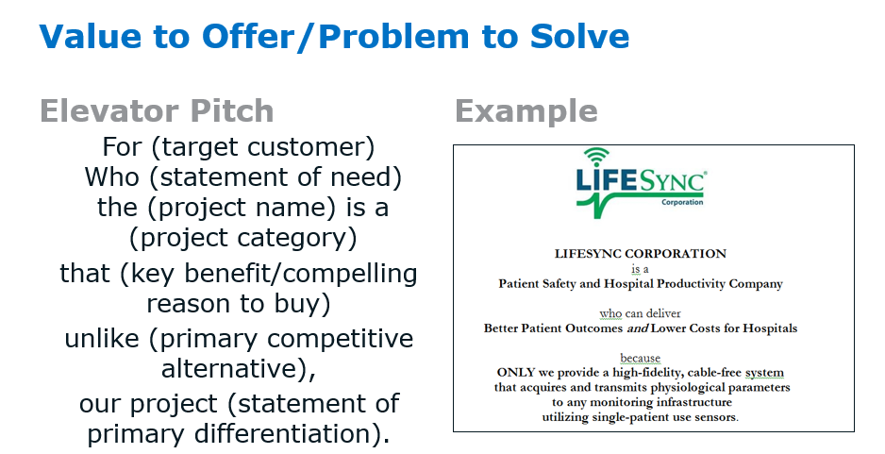

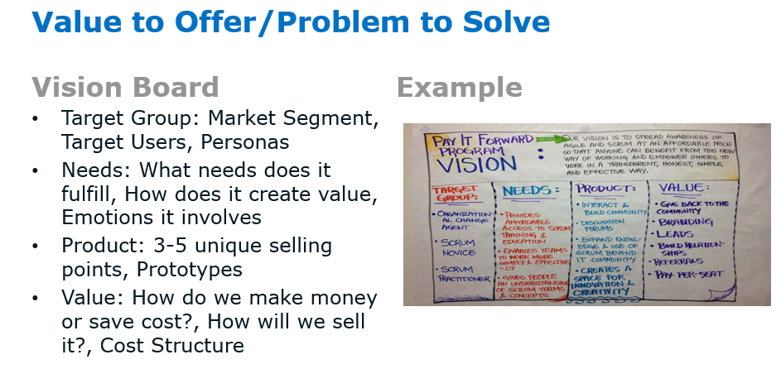

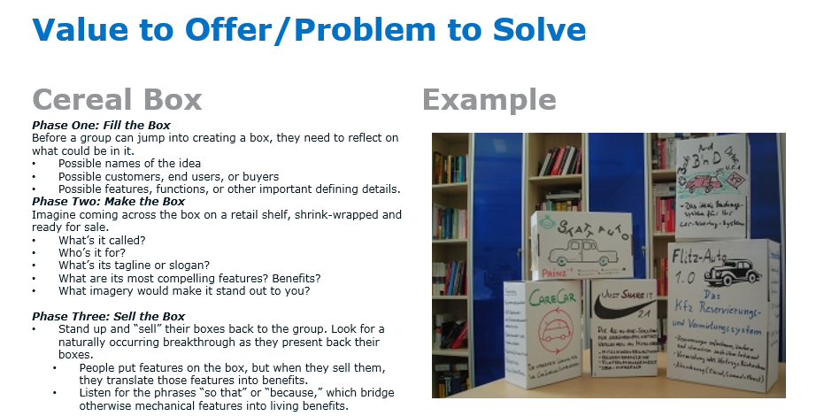

**Self-Assessment**

* Describe at least three criterion to consider for ordering the backlog.[7]
* Describe at least three techniques to order the backlog.[8]

1. Scrum Book of Knowledge, [www.scrumstudy.com](http://www.scrumstudy.com)
2. Agilexicon, <http://www.innolution.com/resources/visual-agilexicon-attribution>
3. SBOK
4. SBOK
5. SBOK
6. SBOK
7. CSPO Learning Objectives 2017, [www.scrumalliance.org](http://www.scrumalliance.org)
8. CSPO