**Product Owner**

The Product Owner is responsible for maximizing the value of the product and the work of the Development Team. How this is done may vary widely across organizations, Scrum Teams, and individuals.[1]

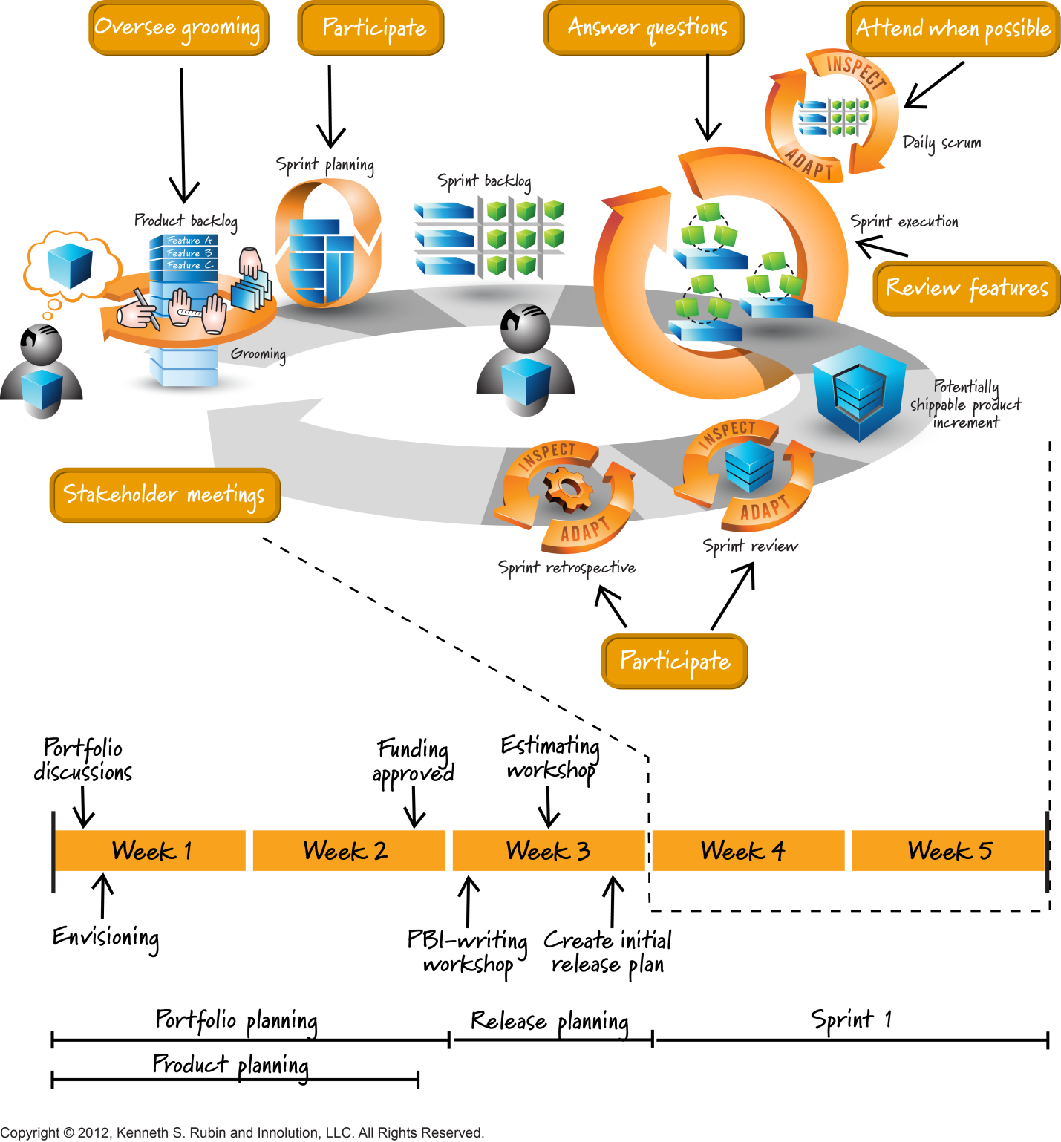**[2]**

The Product Owner is the sole person responsible for managing the Product Backlog. Product Backlog management includes[3]:

* Clearly expressing Product Backlog items;
* Ordering the items in the Product Backlog to best achieve goals and missions;
* Optimizing the value of the work the Development Team performs;
* Ensuring that the Product Backlog is visible, transparent, and clear to all, and shows what
* the Scrum Team will work on next; and,
* Ensuring the Development Team understands items in the Product Backlog to the level needed.

The Product Owner may do the above work, or have the Development Team do it. However, the

Product Owner remains accountable. [4]

The Product Owner is one person, not a committee. The Product Owner may represent the desires of a committee in the Product Backlog, but those wanting to change a Product Backlog item’s priority must address the Product Owner.[5]

For the Product Owner to succeed, the entire organization must respect his or her decisions. The

Product Owner’s decisions are visible in the content and ordering of the Product Backlog. No one is allowed to tell the Development Team to work from a different set of requirements, and the Development Team isn’t allowed to act on what anyone else says.[6]

The Product Owner is the person responsible for maximizing business value for the project. He or she is responsible for articulating customer requirements and maintaining business justification for the project. The Product Owner represents the Voice of the Customer. Corresponding to a Product Owner role in a project, there could be a Program Product Owner for a program or a Portfolio Product Owner for a portfolio.[7]

**Assessment: Product Owner Responsibilities[8]**

1.  **Responsibilities**

* **Drives Product Success**: Identify how the Product Owner will drive product success by maintaining the Product Backlog and guiding the Team with up-to-date knowledge of user and market need.
* **Creates the Product Vision**: Describe how the Product Owner creates a Product Vision and shares it with the Team to provide it with a clear goal. Analyze how the creation of a Product Vision can motivate a Team to deliver a high quality product.
* **Creates and Maintains the Product Backlog**: Identify the responsibility of the Product Owner to create an initial Product Backlog, and refine and continuously maintain it. The Product Backlog should be regularly updated as new information is uncovered.
* **Collaborates with the Team**: Define and describe the Product Owner’s responsibility to continuously collaborate with the Team to better understand requirements and support the Team to identify how to solve them.
* **Collaborates with Stakeholders**: Define different types of stakeholders and describe how the Product Owner facilitates collaboration between all stakeholders.
* Participates in Sprint meetings: Identify the requirement for the Product Owner to participate in both the Sprint Planning meeting and the Sprint Review meeting and that the Product Owner may also participate in the Daily Scrum meeting and Sprint Retrospective.

2. **Authority**

* Define and describe the Product Owner’s authority over the Product Backlog items and their priorities. Also describe the Product Owner’s authority in determining when product increments will be released, without overruling Team’s estimated effort required to complete those increments and without violating the Sprint commitment.

4. **Single Overall Product Owner per Product**

* Define the role of the Product Owner in achieving the objectives of the Sprint.
* Describe the importance of having a single person playing this role.

5. **Organizational Respect**

* Identify that the Product Owner should be given the authority to make the necessary decisions to achieve the ROI on the Product, as described in the Scrum Framework.

*Note: This is the view of the Product Owner from the Scrum Master/Scrum Process point of view. For more information about the Product Owner position, see CSPO Learning Objectives at Scrumalliance.org and Product Owner training class.*

1. Scrum Guide 2013, [www.scrumguides.org](http://www.scrumguides.org)
2. Graphic from Visual AGILExicon, which is a trademark of Innolution LLC and Kenneth S Rubin. http://www.innolution.com/resources/visual-agilexicon-attribution
3. SG
4. SG
5. SG
6. SG
7. A Guide to Scrum Book of Knowledge (SBOK Guide) 2013ed., [www.scrumstudy.com](http://www.scrumstudy.com)
8. CSM Content Outline and Learning Objectives, [www.scrumalliance.org](http://www.scrumalliance.org)