**Definition of “Ready”**

Product Backlog items that can be “Done” by the Development Team within one Sprint are deemed “Ready” for selection in a Sprint Planning.[1] Product Backlog items usually acquire this degree of transparency through the refining activities.[2] Also known as backlog grooming activities.

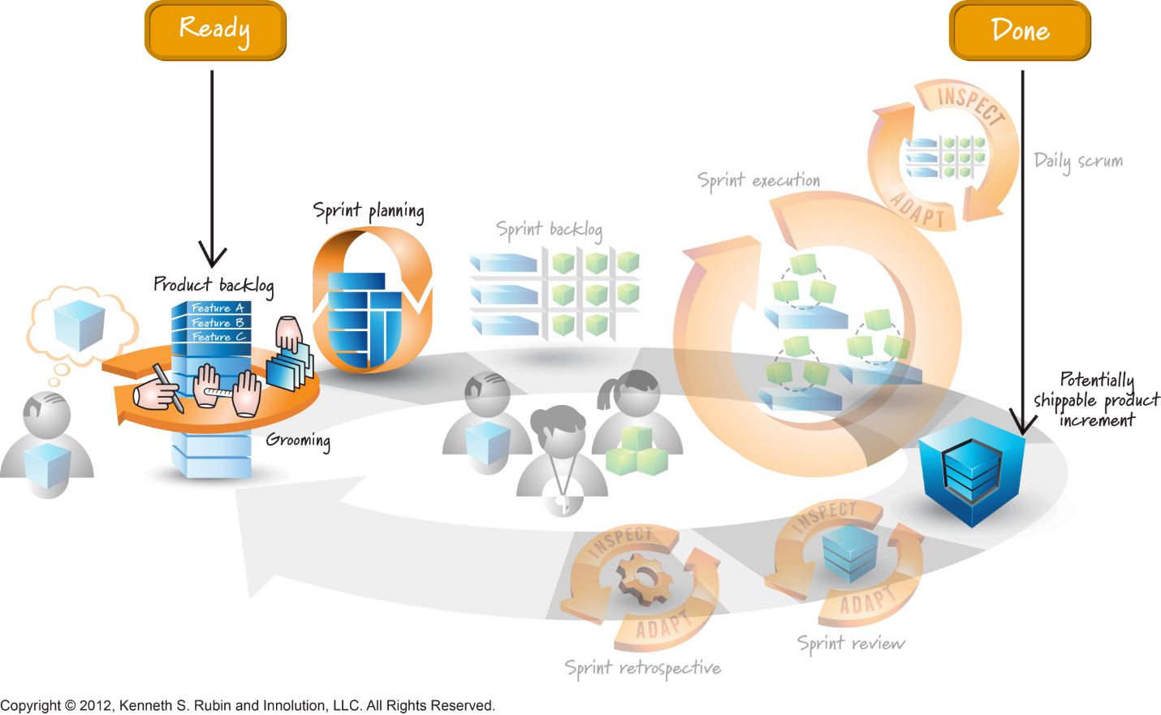[3]

The team makes explicit and visible the criteria (generally based on the INVEST[4] matrix) that a user story must meet prior to being accepted into the upcoming iteration. Just as completed items which fit the definition of "done" are said to be "DONE-done", items that fit the definition of ready are called "READY-ready"[5].

**Self-Assessment**

* **Item Readiness**: Describe that, in order for an item to be considered ready for inclusion in a Sprint, each Product Backlog item should be small enough to fit into a Sprint and must be clear in the expectations of the Product Owner (i.e., by specifying acceptance criteria).[6]
* Describe how to refine larger product backlog items into smaller ones that are “ready” to be built by the development team in a sprint.[7]

1. Scrum Guide July 2016, [www.scrumguides.org](http://www.scrumguides.org)
2. SG
3. Visual Agilexicon, <http://www.innolution.com/resources/visual-agilexicon-attribution>
4. Bill Wake, INVEST <http://xp123.com/articles/invest-in-good-stories-and-smart-tasks/>
5. <http://guide.agilealliance.org/guide/definition-of-ready.html#sthash.UMrFWmvg.dpuf>
6. CSM Learning Objectives, [www.scrum.org](http://www.scrum.org)
7. CSPO Learning Objectives 2017, [www.scrumalliance.org](http://www.scrumalliance.org)